**Barron’s Let’s Review Regents – Algebra I**

# Chapter 7: Linear Inequalities

## 7.1 One-Variable Linear Inequalities

A linear equation line has just one solution, . This changes when the = is replaced with a > or a <. The inequality does not have 8 as a solution, but it does have many other solutions, including 9, 10, and 11. Solving one-variable linear inequalities is very similar to solving one-variable linear equations with one important exception – dealing with negative coefficients.

**When both sides of an inequality are divided by a negative number, the direction of the inequality sign must be reversed.** For example, it is true that  
 6 > 4. However, if both sides are divided by -2, the inequality would say -3 > -2, which is not true.

**Example 1**

What is the solution set to the inequality   
?

**Example 2**

What is the smallest integer that is a solution for x in the inequality   
Answer: 5

**Example 3**

If and x = -2, what is the greatest integer value for a stat satisfies this inequality?  
  
(1) -6

### Check Your Understanding of Section 7.1

1. Multiple-Choice
2. What is the solution set for   
   **(3)**
3. What is the solution set for ?  
   **(1)**
4. What is the solution set for ?  
   **(3)**
5. What is the solution set for ?  
   **(3)**
6. What is the smallest integer that satisfies the inequality ?  
   **(2) 4**
7. What is the smallest integer that satisfies the inequality ?  
   **(2) 3**
8. What is the greatest integer that satisfies the inequality ?  
   **(3) 6**
9. What is the greatest integer that satisfies the inequality ?  
   **(2) 7**
10. Which number satisfies the inequality   
    ?  
    **(4) -4**
11. What is the smallest number that satisfies the inequality ?  
    **(1) -15**
12. Show how you arrived at your answers.
13. Graph the solution set to the inequality   
     on a number line.  
    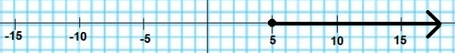
14. Alejandra says that has the solution set . Lorenzo says that it has the solution set . Which student is correct and why?  
      
    **Lorenzo is correct.**  
    **When both sides of an inequality are divided by a negative number, the direction of the inequality sign must be reversed.**
15. Genevieve solves the inequality the following way:  
      
    Is this a valid way of finding the solution set? Explain why or why not.  
      
    **Her method produces the correct answer, but it is a long way to do it. Also, the steps involve the Addition Property of Equality. Whether this property can be extended to inequalities appears to work.**
16. What is the solution set of the inequality
17. Josephine has $60 and wants to go to a restaurant. The bill, including a 20% tip, must be no more than $60. The inequality for what the price of the meal without the tip is   
    . What is the solution set for this inequality?

## 7.2 Graphing Two-Variable Linear Inequalities

The graph of a linear equation, like , is a line. When the = is replaced by a or , the graph becomes a *half plane*. The process of creating the graph for the solution set to the inequality first requires graphing a line and then deciding which side of the line to shade.

**Graphing Inequalities Involving or Signs**

The equation :

When the = sign is replaced with the symbol, it becomes the two-variable inequality .

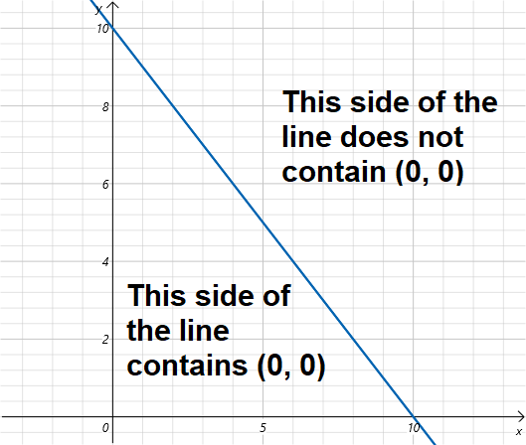

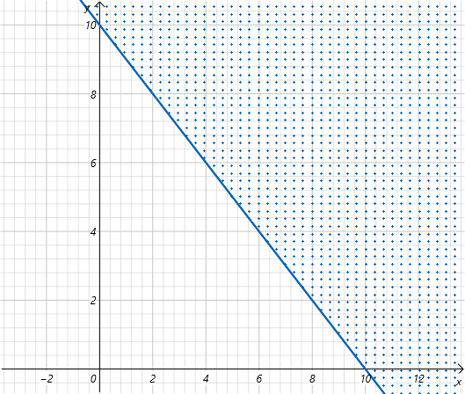

**Example 1**

Graph the solution set to the inequality .

First, graph the line , which will be the boundary between the shaded and unshaded regions.  
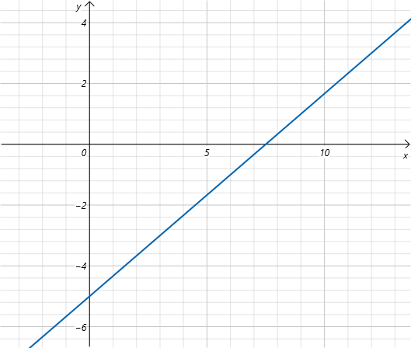

Since (0, 0) is not on the line, test to see if (0, 0) satisfies the inequality.

Since 0 is greater than -5, (0, 0) is part of the solution set. Shade the side of the line that contains (0, 0).

**Graphing Inequalities Involving > or < Signs**

When the two-variable inequality contains a > or < sign, the only difference is that when the line is graphed it must be a dashed line. For the inequality , the ordered pair (2, 8) does not make it true since 2 + 8 is equal to 10, not greater than 10.

Check (0, 0) to determine whether to shade the side containing (0, 0) or the other side of the dashed line.  
Since this is not true, shade the side of the dashed line that does not contain (0, 0).

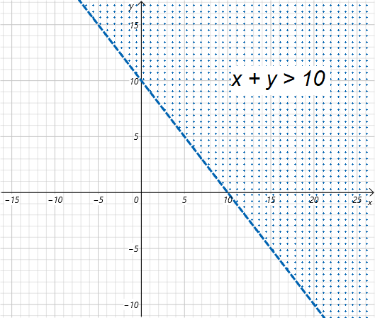

If the symbol in a two-variable inequality is a greater than sign (>) or a less than sign (<), the line separating the shaded half plane from the unshaded half plan will be dashed. If the symbol is a greater than or equal to sign () or a less than or equal to sign (), the line will be solid.

**Graphing Two-Variable Inequalities on the Graphing Calculator**

### Check Your Understanding of Section 7.2

1. Multiple-Choice
2. Which is the graph of y < x + 4.  
   **(4)**
3. Which is the graph of ?  
   **(1)**
4. This is the graph of which inequality?  
   **(2)**
5. Which is the graph of the inequality   
   ?  
   **(1)**
6. Which is the graph of ?  
   **(2)**
7. Which is the graph of ?  
   **(2)**
8. Which is a solution to the inequality  
   ?  
   **(2) (12, 8)**
9. Below is a graph of . Which is a point in the solution set?  
   **(4) (3, 5)**
10. All of these ordered pairs are part of the shaded region for the graph of   
     except  
    **(3) (5, 3)**
11. Which point would not be a good point for checking which side of the line to shade for inequality ?  
    **(2) (0, 4)**
12. Show how you arrived at your answers.
13. A small elevator has a capacity of 4 people. On the graph below, make points indicating valid combinations of men and women who could be in the elevator.  
    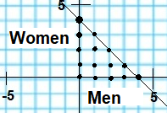
14. What is the inequality that has this solution set?  
    Point 2: (2, 4)  
    Point 1: (0, 3)  
    Check with (0,0)
15. Ryan is graphing the solution set to the inequality . After drawing the line   
    , he tests the point (0,0) and finds that   
     is true. Does he now have enough information about which side of the line to shade? Explain.  
      
    No. (0, 0) is on the line. The procedure suggests or requires that a point is picked that is not on the line and this allows determining which section to shade. A better point would be (0, 1).
16. Graph the solution set for the inequality   
    . Dividing by -1 gives:  
    Points for:

|  |  |
| --- | --- |
| **x** | **y** |
| 0 | 4 |
| 2 | 0 |

Check for (0, 0)  
 is false.  
  
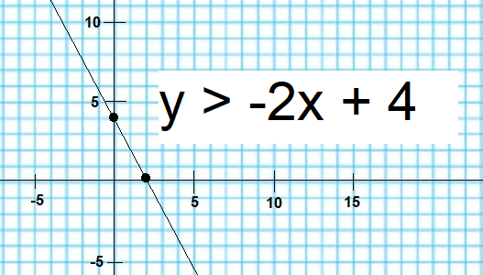  
  
1. Juice costs $2 a point. Milk costs $3 a pint. If you have $12, make a graph that shows all possible combintaions of juice and milk you can purchase.  
   x = number of juice pints  
   y = number of milk pints

|  |  |
| --- | --- |
| x | y |
| 0 | 4 |
| 6 | 0 |

